Empirical study: Bussière et al. (2006)

Bussière, Matthieu, Marcel Fratzscher & Gernot J. Müller (2006): “Current account dynamics in OECD countries and in the New EU Member States: an intertemporal approach”, Journal of Economic Integration, vol. 21, no. 3, pp. 593-618.

Main insight from the intertemporal approach to the balance of payment (cf. O&R, ch. 1)
→
Smoothing of consumption ⇒ intertemporal substitution of consumption between periods
→
- If “bad times” (i.e. future better) ⇒ current account ↓
- If “good times” (i.e. future worse) ⇒ current account ↑

NB: Many caveats
- Relative to other countries (symmetric vs. idiosyncratic shocks)
- Investments
- Government
- …

One more caveat
→

Perhaps more or less know production this year, but what about next year?
⇒
Many empirical studies of current accounts dynamics and the intertemporal approach → complex forecasting of (expected) production levels following year(s)
⇒
Empirical models become very complicated ☹
→
Bussière et al. (2006) make easier choices! ☺

Read paper!

I. Introduction

“The past decade has seen a strong increase in theoretical and empirical work on the determinants and dynamics of the current account. Much of the rise of this literature has come from the conceptual progress made in open economy macroeconomics, and in particular on the intertemporal approach to the current account that was initially proposed by Sachs (1981) and thoroughly extended by Obstfeld and Rogoff (1995, 1996).”

II. Theoretical framework

Much like O&R, ch. 1
- … infinite horizon ← “solves” some problems, creates new ones
- Habit persistence ⇒ lagged current account / lagged dependent variable matters
- Government borrowing important (because non-Ricardian equivalence due to liquidity constraints) ⇒ budget deficits matter

III. Data and Estimation Issues

Panel data
- Cross-sectional sample: 33 countries → “ten new EU Member states, plus Bulgaria and Romania, and 21 OECD countries”
- Time sample → yearly data from 1980-2002 ← unbalanced sample! ☺/☹

WEO database = World Economic Outlook database (updated every half year by the IMF)

Dynamic panel data estimations

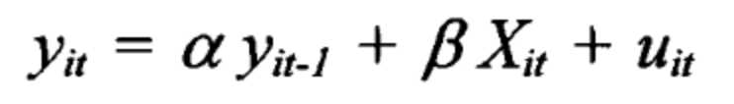

LHS variable (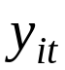) → Current account (% of GDP)

RHS variables (baseline)
- current account (-1)
- fiscal surplus
- Δ net_surplus ← domestic resources for consumption 
- rel. income = income relative to comparison group
- investment ratio
- public spending ratio

Δ net_surplus

net_surplus = relative GDP – investments – public spending ← (relative) domestic production available for private consumption

relative to average of sample countries (pp. 602-603)

Δ net_surplus = net_surplus – net_surplus (-1)

Δ net_surplus ↑ ⇒ lots of domestic production available for private consumption (relative to other countries in the sample) compared to last year

NB: Δ net_surplus is called Δ net_output in the tables!

Time series properties

Nice if variables are I(0) → tests for panel stationarity…
Estimation issues

- LSDV ← Least Squares Dummy Variables

Lagged dependent variable → Nickell bias
- NB: Potentially also endogeneity bias
→

Two instrumental variables estimators
- IV = Anderson and Hsiao estimator ← instrument differenced model with one-period lagged level
- GMM = Arellano-Bond GMM = AB GMM ← instrument differenced model with expanding lags of level variables

IV. Results and Structural Current Account Positions
Anderson-Hsiao
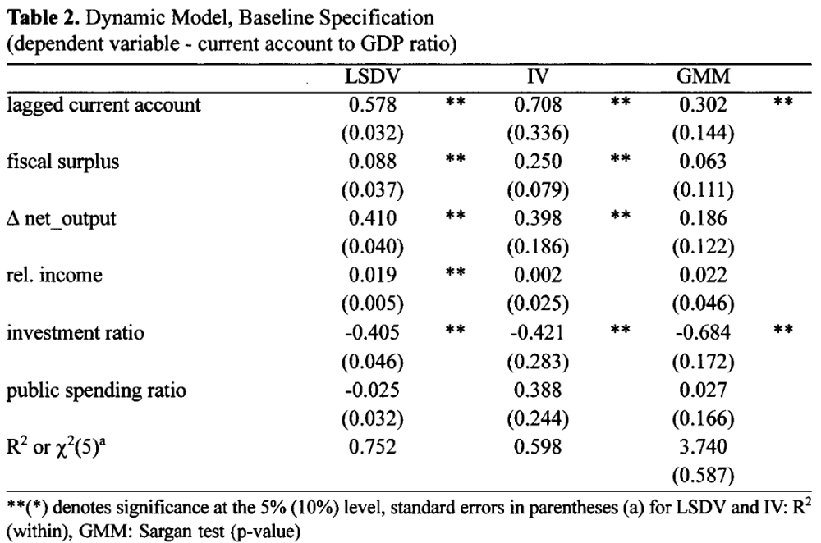

Results
- Substantial persistence
- fiscal surplus
- Δ net_surplus ← cannot reject theory of intertemporal substitution
- relative income
- investment ratio

Robustness checks → remove fiscal surplus in 1st and add covariates in 2nd and 3rd columns

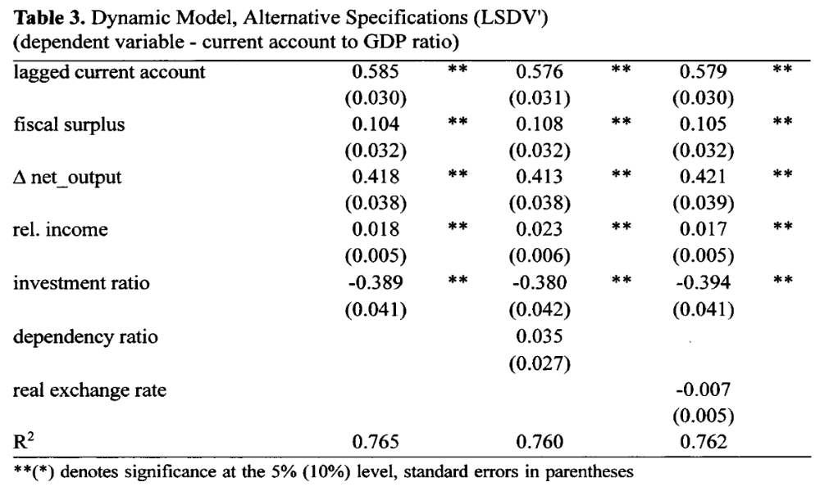

NB: Karsten could think of many other interesting robustness analyses!

Short-term vs. long-term

NB: Coefficient estimates in Tables 2 and 3 → short-term / instantaneous effects

Compute “long-term effects” → on whiteboard!
- NB: Shaky stuff as most or all independents regressors are endogenous ☹

V. Conclusion

- Study cannot reject the intertemporal approach
- Study cannot reject persistence in current account (presumably because of persistence in consumption, habit formation)
- Study cannot reject other factors besides basis intertemporal substitution model

NB: Nothing “proved” or “proven” ← this is an empirical study! [← Discuss]

